The Sounds of the Stars

Subjects and topics:
- Music: Pitch, Intervals, Melodic sequences, Rhythm
- Astronomy: The Orion Constellation.
- Physics: Heat Transfer, Energy, Waves.
- Mathematics: Data Analysis and Statistics.
- Information and Communication Technologies: Digital Literacy, Data Sonification, Multimedia.
- Arts: Visual representations and reproductions.

Duration: 2 - 8 weeks
Grade level: 12th - 15th
Author of this document: Petros Stergiopoulos

Summary

“Sounds of the Stars” is an interdisciplinary STEAM learning scenario that invites students to explore the fascinating connection between astronomy and music through the process of data sonification — transforming scientific data into sound. Using real astronomical data from the constellation Orion, students investigate how numerical values such as star brightness, temperature, and position can be expressed as musical notes, rhythms, and dynamics. By combining scientific observation with artistic creativity, learners experience the cosmos not only through sight but also through sound.

Throughout the four design-thinking phases (Feel, Imagine, Create, Share), students take on the roles of scientists, composers, and digital creators. They observe the night sky using virtual telescopes, experiment with digital tools like TwoTone, Online Sequencer, and Pureref, and collaboratively produce unique audio compositions that represent stellar data. The project concludes with public sharing and reflection, fostering digital literacy, creativity, and a deeper appreciation for how science and art can work together to make invisible cosmic patterns audible and meaningful.

- FEEL

In this introductory phase, students are invited to explore the beauty of the night sky and to connect astronomy with music. Using digital sky visualization tools such as Stellarium, they locate the constellation of Orion and observe its main stars. The teacher introduces the concept of data sonification – transforming data into sound – by showing examples of how scientific data (e.g., light intensity, temperature, or distance between stars) can be converted into melodies and rhythms.

Next, the class discusses:

- How does the universe “sound”?
- Can scientific data become music?
- What feelings arise when we imagine the stars producing sound?

Students reflect on these questions and brainstorm ideas about what aspects of the Orion constellation they would like to sonify. In groups, they vote on which dataset to use (e.g., star brightness, temperature, or spatial coordinates) and decide on their initial direction.
This phase encourages curiosity and emotional engagement, laying the foundation for co-creation in the next steps.

Supporting presentations:
https://www.schoolofthefuture.eu/el/paratirisiaki-astronomia

RESULTS OF THE FEEL PHASE:

By the end of your implementation, you can add here results from this phase, including pictures, aha moments, quotes from students and other people involved, etc. This can inspire others to design projects as amazing as yours.

- IMAGINE

At this stage, students have become familiar with both the scientific and artistic dimensions of the project. They begin imagining different ways to transform the data of Orion into sound. Working collaboratively, they explore various sonification tools such as TwoTone, Online Sequencer, or Pureref.

- They are encouraged to experiment and propose creative mappings:
- How could star brightness correspond to musical pitch?
- How could the distance between stars shape rhythm or duration?
- Could temperature data be linked to musical instruments or sound timbre?

Students sketch ideas, test short examples using demo data, and document their reasoning. They also consider the social or inclusive impact of their work: for example, creating sound-based astronomy experiences for visually impaired peers, or turning complex astronomical information into accessible art.
All groups share and vote on the most inspiring ideas to develop in the next phase.

Supporting presentation:
https://www.schoolofthefuture.eu/en/node/25156

RESULTS OF THE IMAGINE PHASE:

By the end of your implementation, you can add here results from this phase, including pictures, aha moments, quotes from students and other people involved, etc. This can inspire others to design projects as amazing as yours. You can include here all the ideas from your students. This might help others to solve the problem too.

- CREATE

Now students bring their ideas to life. Each group plans its project in detail — defining tasks, tools, and materials. They collect real Orion data from the provided spreadsheet or online database and upload them to the chosen sonification platform (TwoTone or Online Sequencer).

Students then:

- Map the data to sound parameters (pitch, duration, volume, instrument).
- Experiment with tempo and layering to build musical patterns.
- Export their sound files or MIDI compositions.
- Optionally, visualize their process using Pureref or simple video editing tools.

Teachers encourage an atmosphere of exploration where making mistakes is part of learning. Students revise and refine their compositions, ensuring that all group members contribute equally — from technical setup to creative design.
By the end of this phase, each group has produced a unique “Sound of the Stars” composition representing the Orion constellation.

Supporting material:
See below for detailed videos showing an example of data and “schematic” sonification audio recordings using the two-tones platform: two-tones and the Online Sequencer :

Data Sonification
Uploading Orion Excel data to the two-tones platform and user guide:
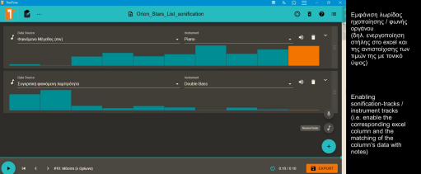 (click on the image for video)

A result as an example:
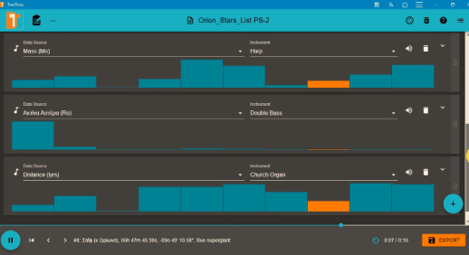(click on the image for video)
Duration / Variation (change of tempo):
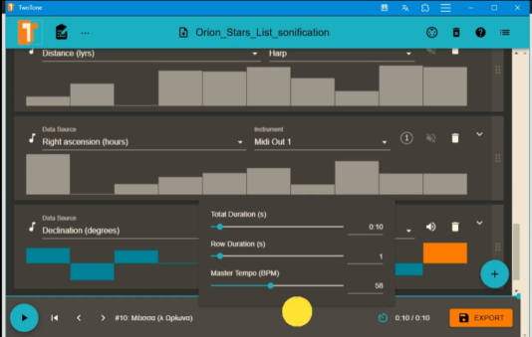(click on the image for video)

Export the audio file to your computer using the "EXPORT" button
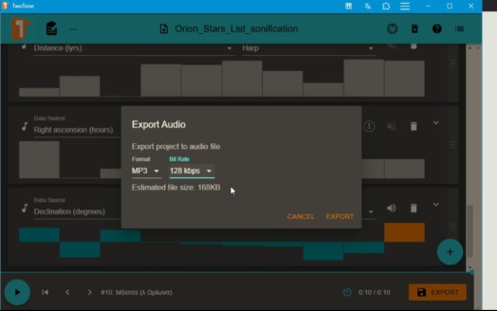(click on the image for video)

Schematic Sonification
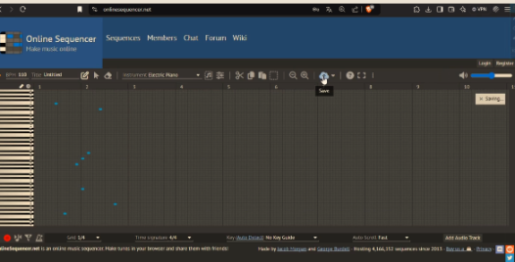(click on the image for video)

RESULTS OF THE CREATE PHASE:

By the end of your implementation, you can add here results from this phase, including pictures, aha moments, quotes from students and other people involved, etc. This can inspire others to design projects as amazing as yours. You can include here pictures from their creations too.

- SHARE

In the final stage, students prepare to present their work to the school and broader community. Together, they identify their audience — classmates, parents, or even online visitors — and design a presentation format: a live performance, digital exhibition, short video, or online gallery.

Students create accompanying materials explaining how they turned astronomical data into music, highlighting both the science and the art behind their process. They may include slides, posters, or QR codes linking to their compositions.

A reflection session concludes the project:

- What did we learn about the relationship between sound and science?
- What challenges did we face, and how did we overcome them?
- How can we improve or extend our sonification next time?

By sharing their creative results at the https://soundscapes.nuclio.org/index.php/community/, students not only celebrate their achievements but also inspire others to experience the cosmos through sound — proving that learning can truly resonate.

RESULTS OF THE SHARE PHASE:

By the end of your implementation, you can add here results from this phase, including pictures, aha moments, quotes from students and other people involved, etc. This can inspire others to design projects as amazing as yours. You can add here pictures of your students sharing their results and write down final considerations.

