Beginnings

Subjects and topics:
- Music: Pitch, Intervals, Melodic sequences, Rhythm
- Astronomy: The Big Bang and the expansion of the universe.
- Physics: Temperature, Energy and expansion data.
- Mathematics: Logarithmic scale.
- Information and Communication Technologies: Digital Literacy, Data Sonification A posteriori, Multimedia.
- Arts: Drama performance, presentations and music reproductions.

Duration: 2 - 8 weeks
Grade level: 12th - 15th
Author of this document: Petros Stergiopoulos

Summary

“Beginnings” is a cross-disciplinary educational activity that transforms cosmological data into music through sonification, offering students a creative and scientific exploration of the history of the universe. The project centers around three key cosmological moments: the origin of the universe (“the beginning”), the decoupling of light and matter, and the present day. Using a logarithmic Cartesian graph, students plotted temperature, energy, and expansion data at these three points in time along a timeline represented by the x-axis. The y-axis, corresponding to a 12-note chromatic musical scale, allowed students to convert scientific values into musical notes. The result was a symbolic and auditory representation of the universe’s evolution.
The activity culminated in a two-minute performance by seven secondary school string students playing violins, violas, and a violoncello. Each student interpreted one of the sonified data points, creating a layered musical experience that encapsulated both scientific precision and artistic expression. A poem, written by the students, complemented the musical composition, adding a narrative, theatrical performance and reflective dimension.

Our SoundScapes project with guidelines for students
- FEEL

380,000 years after the "Big Bang," which we believe created the universe, electrons (negative charge) and protons (positive charge) were free to move, while light particles, photons, constantly collided with these protons and electrons. The protons were unable to bind electrons and form hydrogen atoms because as soon as this happened, a high-energy photon would collide with them and break the bond that held the atom together.

In turn, light could not travel throughout the universe because it was constantly "trapped" colliding with the charged particles it encountered in its path.
So we had a universe with charged electrons and nuclei, and light trapped in an "eternal game of tennis" between them.

However, as the universe expands, its temperature drops. This in turn means that the average energy of photons decreases.
In the 380,000 years after the Big Bang, the temperature of the Universe reached 3,000 degrees Kelvin, and the average energy of photons fell below the significant value of 13.6 electron volts (13.6 eV) . At this energy, photons were no longer able to break the bonds between protons and electrons, so the first hydrogen atoms were formed.
With no free charges to interact with, photons can now travel unimpeded throughout the universe without being stopped by anything.
Light has now been freed from matter, and the universe has become transparent!
https://www.youtube.com/watch?v=vl6-y98L9X0&ab_channel=MichelvanBiezen

This "first light" is what we observe today as cosmic microwave background radiation.

https://www.youtube.com/watch?v=3tCMd1ytvWg&ab_channel=PBSSpaceTime

(M. Chaniotakis)

RESULTS OF THE FEEL PHASE:

By the end of your implementation, you can add here results from this phase, including pictures, aha moments, quotes from students and other people involved, etc. This can inspire others to design projects as amazing as yours.

- IMAGINE

Imagine creating a performance with characters such as the following, accompanied by sound patterns based on the diagram of the expansion of the universe as described at the beginning. The following content can serve as an example that follows a framework for a performance that can be recorded and/or performed on stage.

Poetry A poem was constructed according to the concept narrated by pupils as part of the "Beginnings" Global Science Opera 2024: https://vimeo.com/1038509347

Music

Based on the diagram, students observe the structure and the sizes from which it is constructed. With the help of their teachers, students imagine ways to convert the diagram and the sizes it depicts into sound, studying it as a musical score that is read from left to right.

Example of implementation:
Imagine a graphic score in the form of a Cartesian field, based on the above diagram, in which the dimensions of time, universe expansion, energy and temperature are represented in time divided from left to right into a specific number of equal time intervals (musical/metronomic times). Each variable will be represented linearly by connecting the values corresponding to these common musical/metronomic times. The vertical axis of the field mainly represents the pitch (and possibly the dynamics), while the horizontal axis represents time.

Drama
Characters: Sun, Boy, Girl, Dance, Narrator (all one by one)

Performance script

1 " From the absolute, a burst of energy,
2 A universe born in fire and light.
3 Particles are dispersed, transporting
4 the seeds of galaxies that have not yet formed."
5 "In the chaos,
6 Light escapes from the grip of darkness.
7 The Particles combine to form the first Atoms,
8 as Matter takes form throughout the universe.”
9 “In the heart of the stars, the elements are forged.
10 The Sun stands still, and the planets revolve in its warmth,
11 Life begins to emerge."
12 “Now, we stand among the stars.
13 Humans woven from the very fabric of the universe,
14 We are looking for our origin."

Chorus: “Particles, in cosmic explosion”
Sun: “Time stretches out, and I lead the pulse of life”
Chorus: "Particles dance in the dark, light breaks out and slowly we unite - atoms form in the newborn universe."
Boy: "Did it all start with a spark?"
Girl: “Atoms and stars - yes, we are cosmic dust”
Chorus: “We are stars, planets, life

RESULTS OF THE IMAGINE PHASE:

By the end of your implementation, you can add here results from this phase, including pictures, aha moments, quotes from students and other people involved, etc. This can inspire others to design projects as amazing as yours. You can include here all the ideas from your students. This might help others to solve the problem too.

- CREATE

Music

Strings:
The score of the recording is created by logarithmically calculating the sizes of the diagram on the twelve-tone musical scale. The lines of the sizes as they are represented in the Cartesian field (graphic score) also form the tonal heights as they evolve over time.
Implementation: A student string ensemble, in collaboration with the music teacher, performs the notes resulting from the points on the lines and the four sizes at the three suggested moments in time in this scenario (Beginning of the Universe, Separation of Light and Matter, Today) in the form of a cluster.
The three results of the sound recordings are videotaped and placed at the beginning, middle, and end of the performance. Example of analysis here.
The two axis are as follows:
X-axis : 19 times of a musical piece (as of 19 beats of a slow metronome)
Y-axis : 12 notes of the chromatic scale within one octave = SOL /SOL' (the same scale is used for dynamics instead of pitch_scale)
Sonification protocol: The matching of musical chords and values was determined based on the above graph and “A posteriori” (data were given before the sonification procedure).
Duration of the piece: 2 minutes. Instruments: 7 string students (high school/secondary school).

Chorus

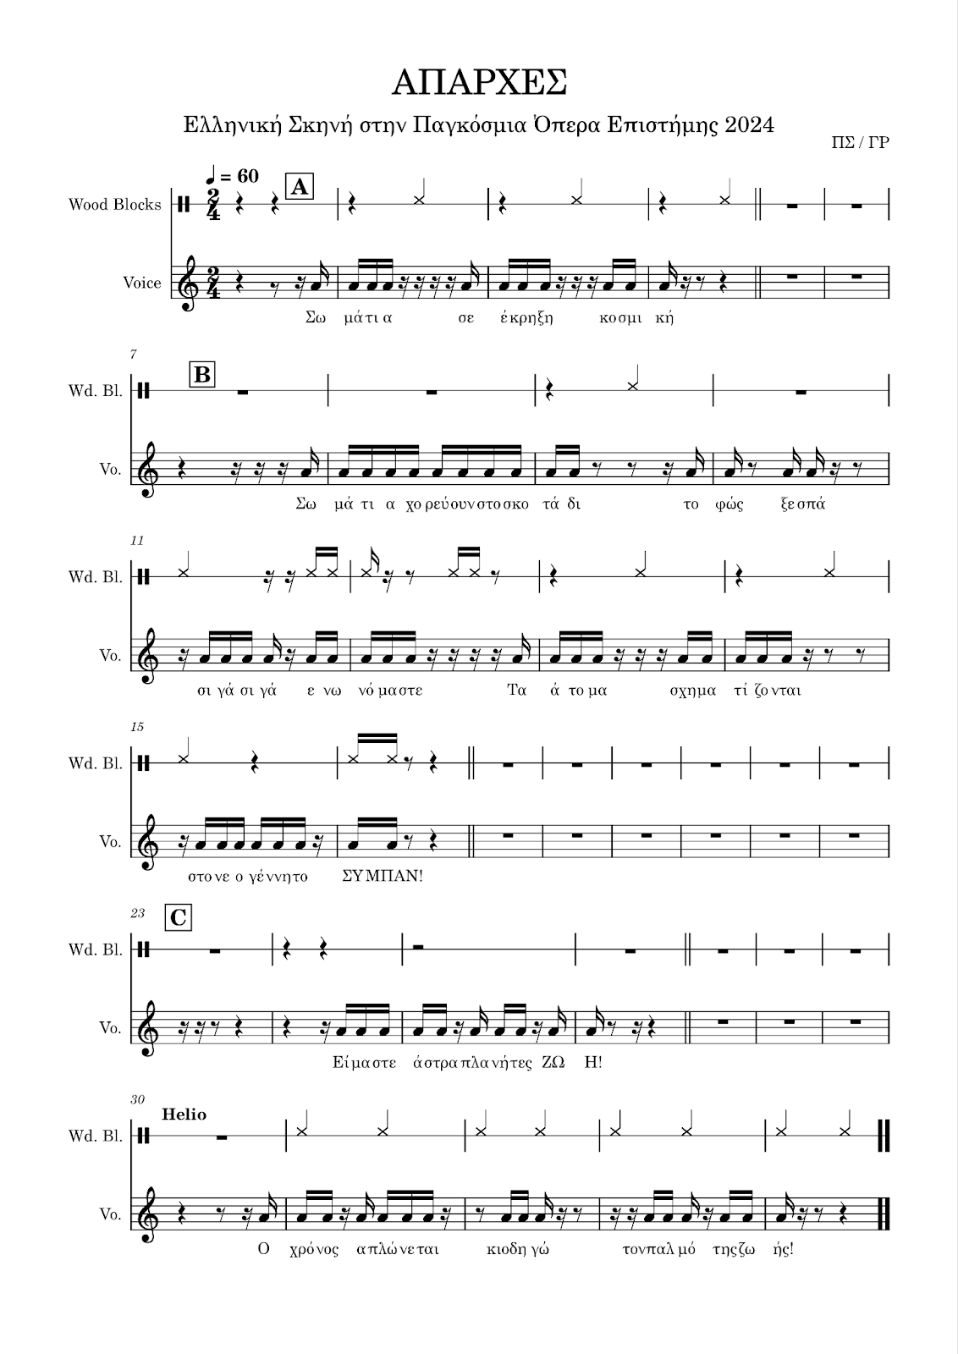
Figure 1 Example of lyrics performed rhythmically

Performance practice

Instructions: One camera is set up to be stationary. A second camera is mounted on a stick and can be moved around. A microphone is set up and the screen displays the lyrics. We enter the classroom and remain quiet, as everything must be carried out with discipline for half an hour. We sit amphitheatrically with an empty seat to our right so that we can hit a sound tube (e.g., boomwhacker) if we have one, and move to the microphone position if necessary.

About the Narrator
The students are numbered one by one and look at their lyrics. They prepare them mentally. Those who have the same number come forward together. One by one, we go to the microphone and recite a line from the narrator.

About the Chorus
The students perform the lyrics A, B, C that they see on the screen with the teacher's guidance.

About the roles of "boy," "girl," "sun," and "chorus of particles":
The teacher explains the roles of "boy," "girl," "sun," and "chorus of particles" after reading them aloud to the whole class. The staging is done ad hoc.

RESULTS OF THE CREATE PHASE:

By the end of your implementation, you can add here results from this phase, including pictures, aha moments, quotes from students and other people involved, etc. This can inspire others to design projects as amazing as yours. You can include here pictures from their creations too.

- SHARE

The event is part of the global science opera initiative that allows the dissemination of the result in a global audience. The final scene was filmed as part of the GSOrt practice (Global Science Opera in real time) and can be seen here: https://vimeo.com/1038509347 (navigate to 28:58)

RESULTS OF THE SHARE PHASE:
By the end of your implementation, you can add here results from this phase, including pictures, aha moments, quotes from students and other people involved, etc. This can inspire others to design projects as amazing as yours. You can add here pictures of your students sharing their results and write down final considerations.

